2017-18 FIRST Robotics Grant
Michigan Electronic Grants System Plus (MEGS+)

Step 1. Log-in to MEGS+

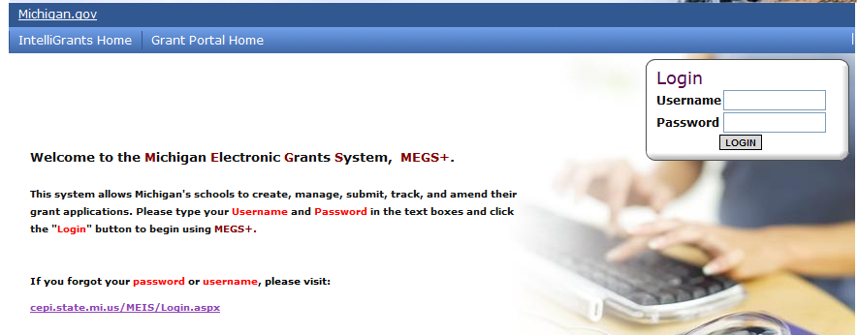
Step 2. Click view available Applications/Tasks

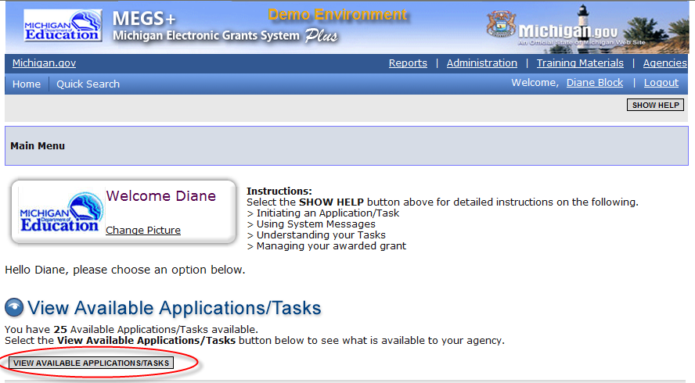

Step 3. Initiate the Application and Agree

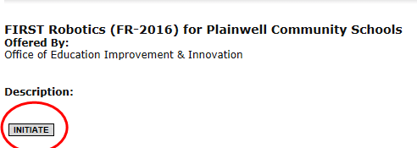

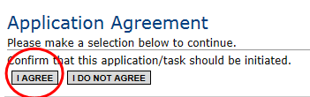

Step 4. View and Edit Application
a. Click View and Edit

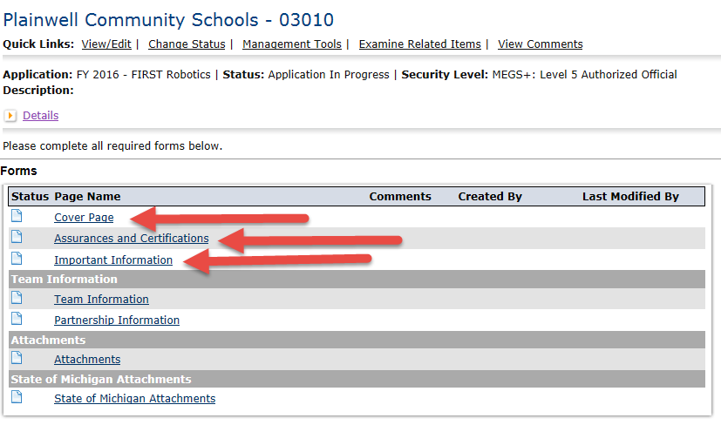
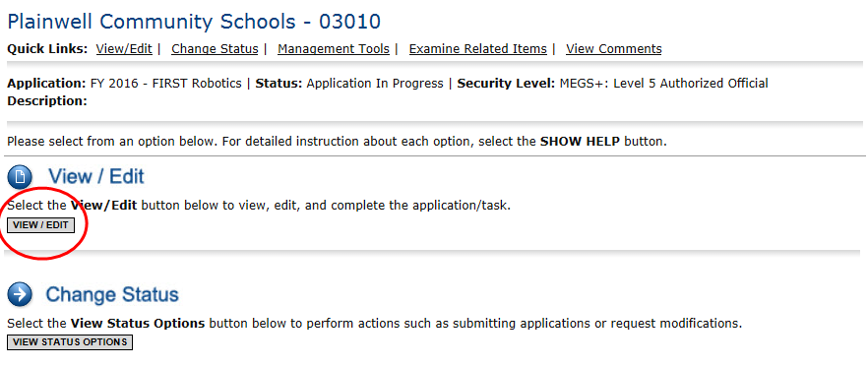
b. Review Cover Page, Assurances and Certifications, and Important Information

Nonpublic Schools Only: complete the competition selection page prior to completing step 4.c (Team Page).
Public School Applicants will not see this link on the view/edit page.
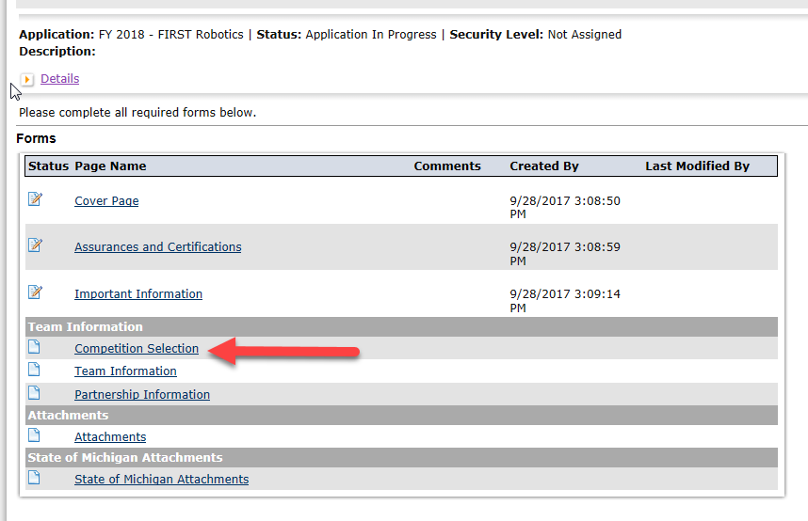

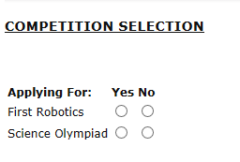

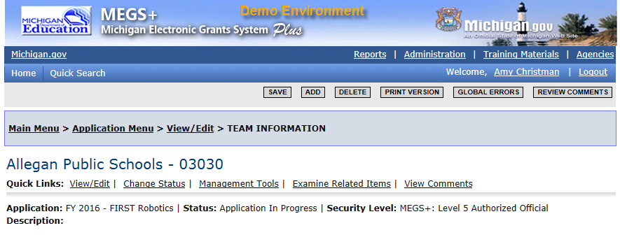
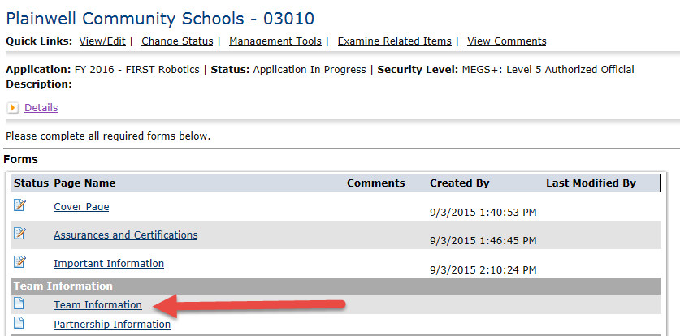
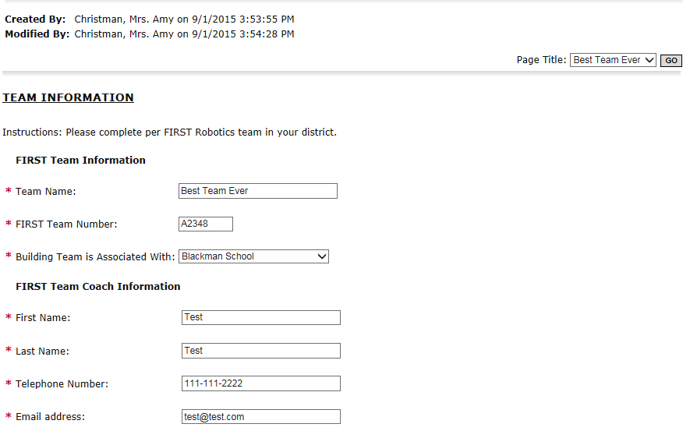
c. Complete Team Information Page
Make sure the title page does not state “Untitled”. It must have a team name.

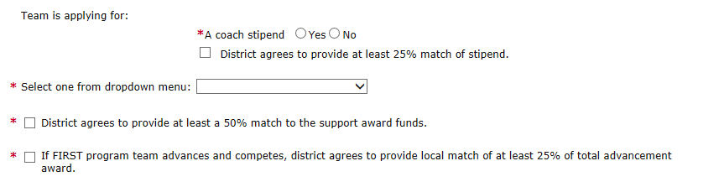
If yes, you must agree to provide the match. Indicate acknowledgment by checking the box. If no, then do not check the box.

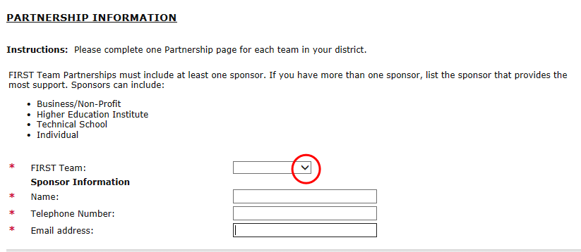
d. Complete Partnership Information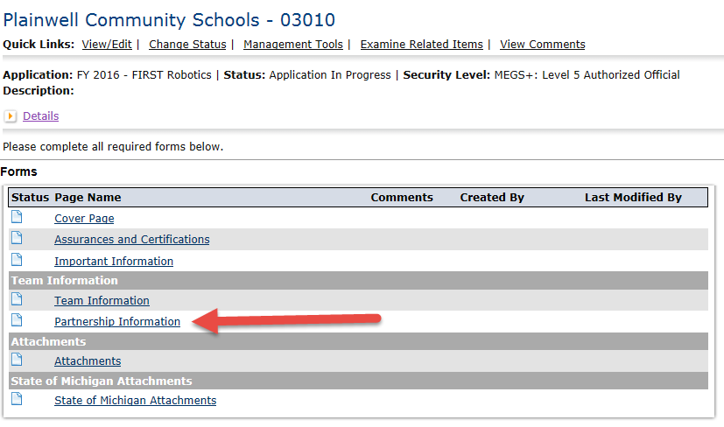
Complete the Team Page first in order to generate the dropdown options.
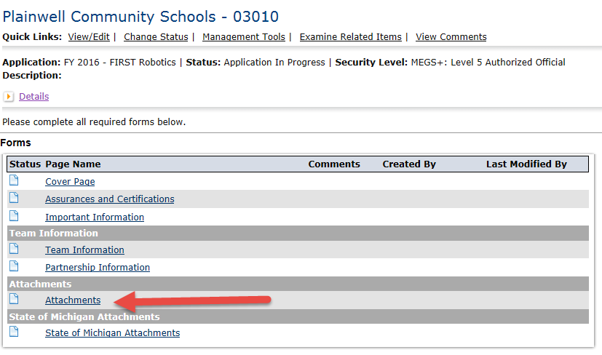
e. Upload Attachment – Only the Spending Plan is required at the time of submission. The Team Roster will be uploaded at the end of the season as an amendment to the application.

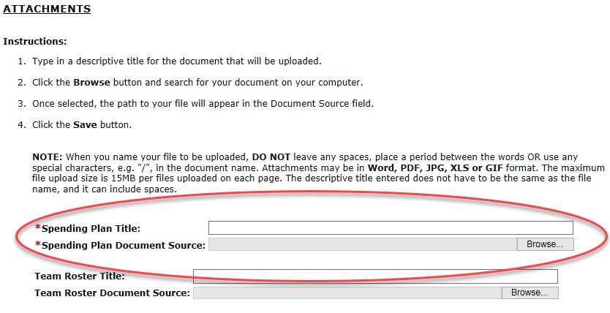
Step 5. Add Main Contact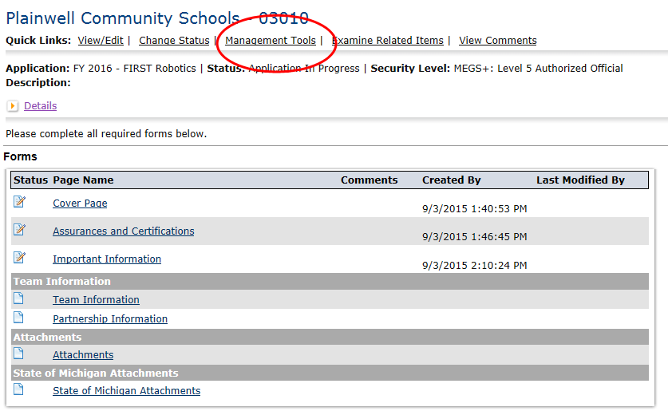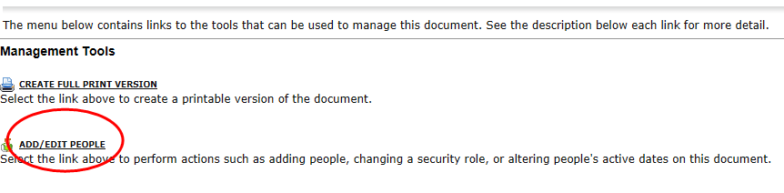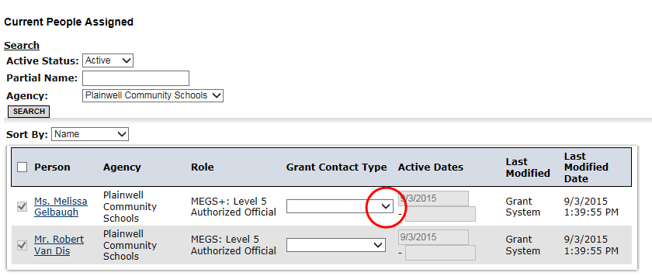

Step 6. Check for Global Errors
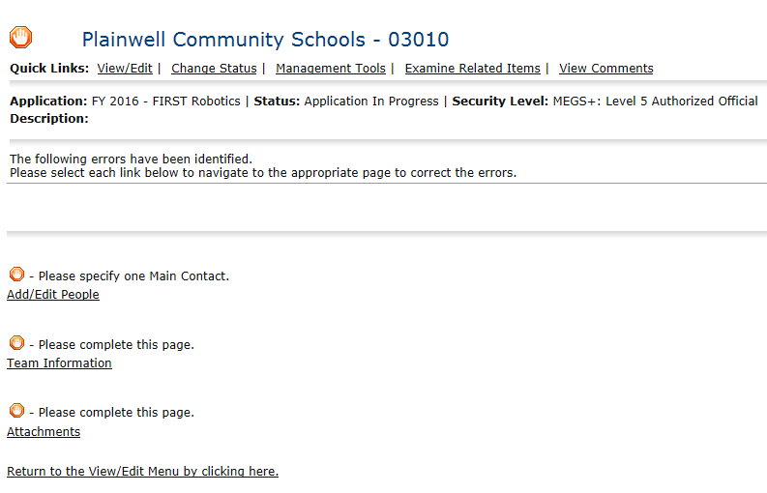

Step 7. Submit the Application
