2021-22 99h: Robotics Grant
NexSys

Step 1: login to NexSys - MILogin - Login (michigan.gov)
Note: If you do not have a MEIS ID, log-in, or password visit: https://www.michigan.gov/mde/0,1607,7-140-5236_29341---,00.html
Step 2: Select 99h: Robotics Competition Program listed under My Opportunities. Note: You must be a level 5 to initiate the application.

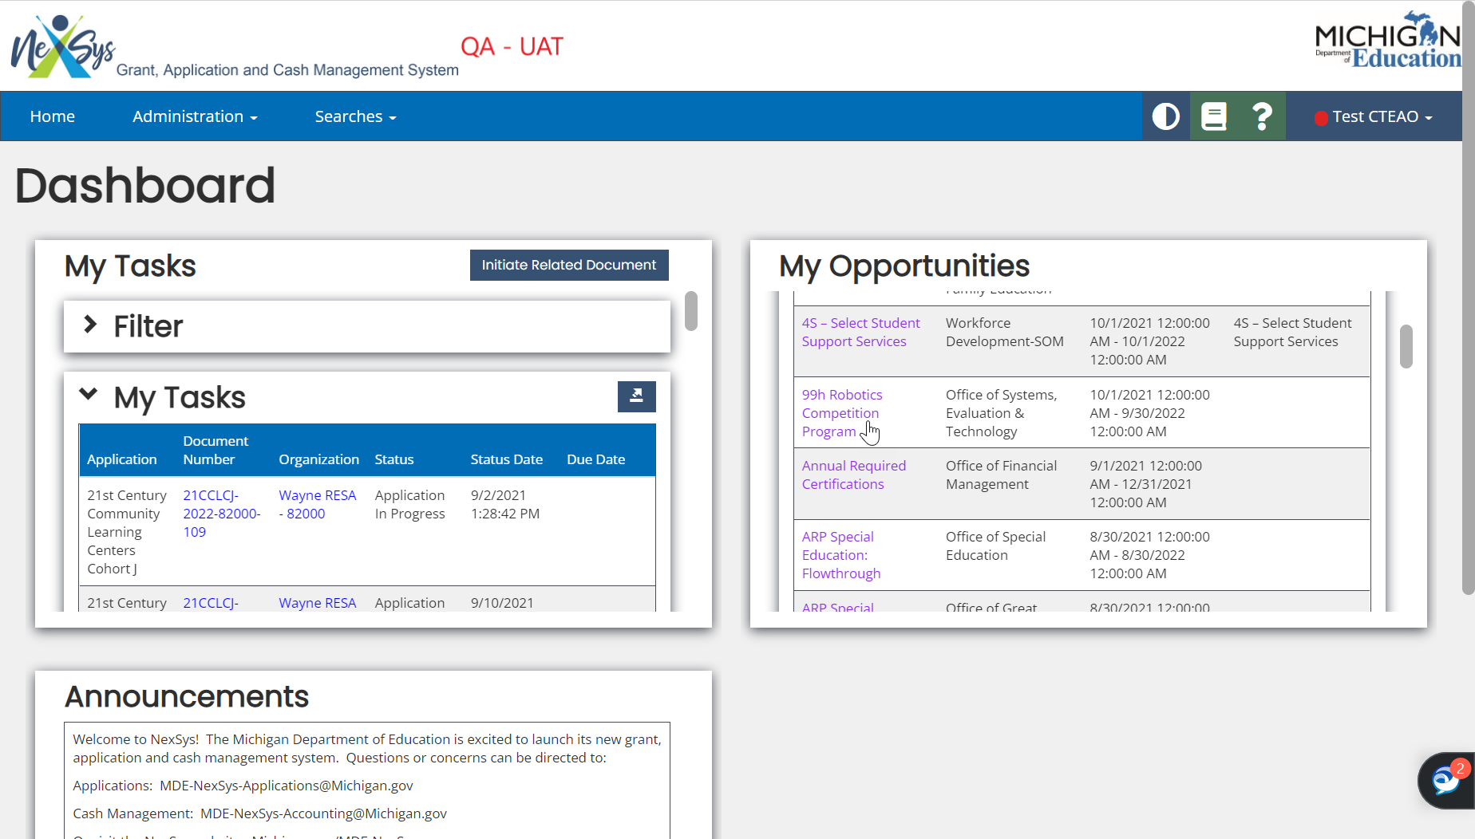

Step 3: Confirm the information and click Proceed 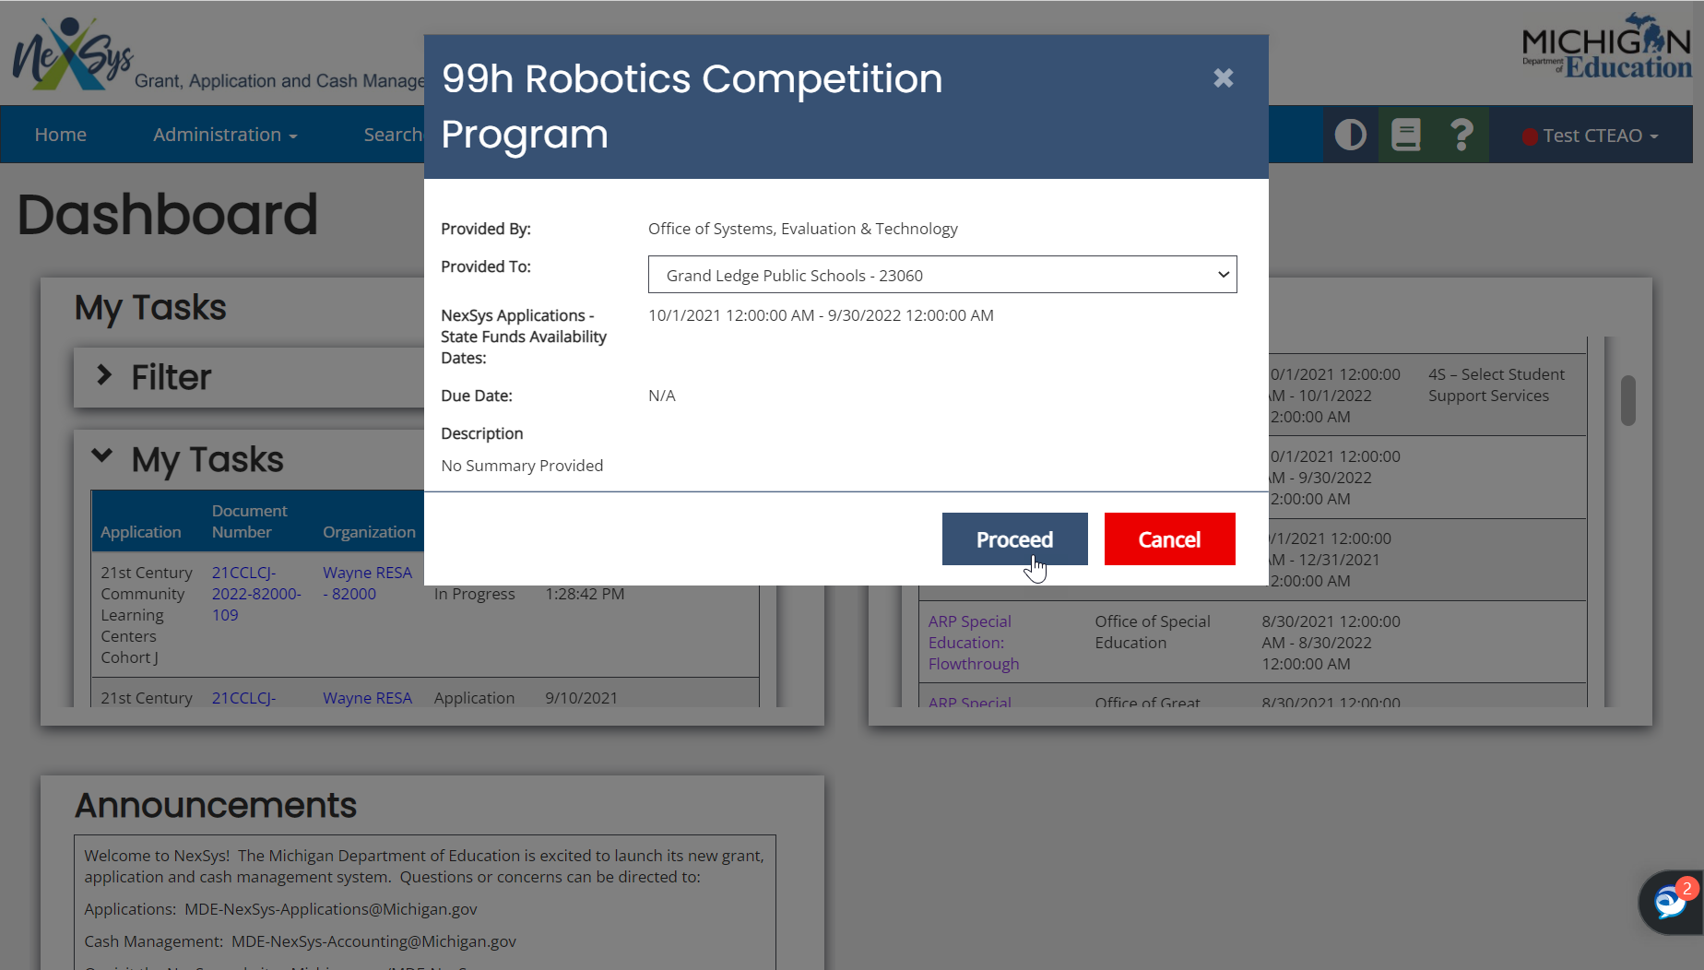
Step 4: You will be taken to the Document overview page. From the left-hand side navigation pane click on Cover Page.
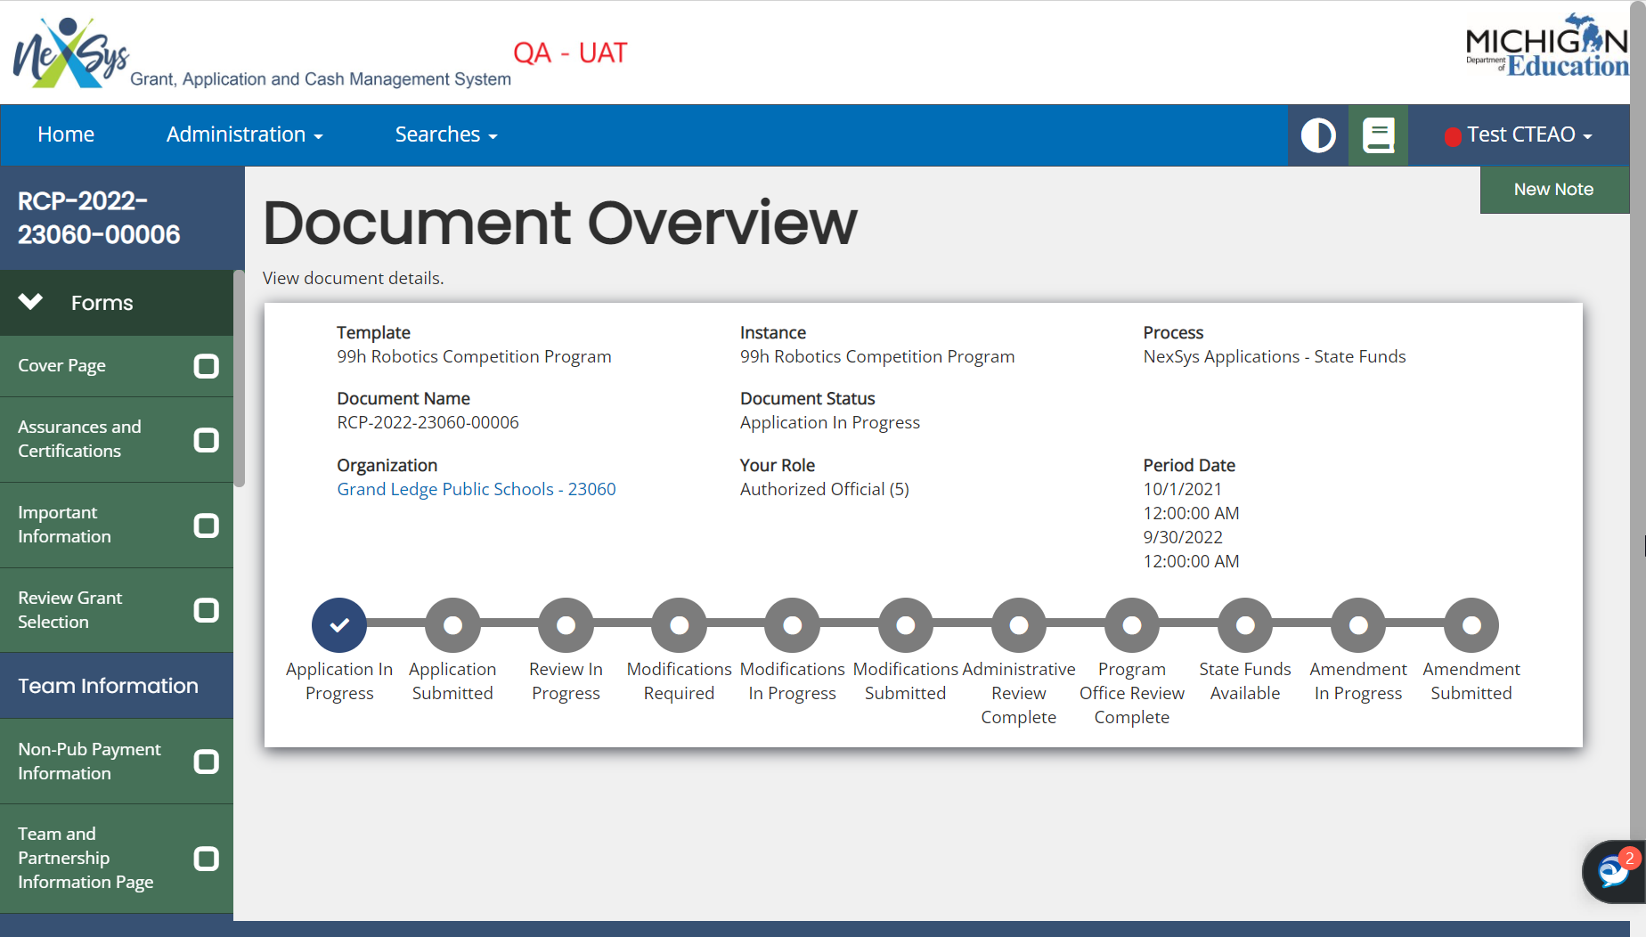

Step 5: Review the Cover Page. Scroll to the bottom to enter your contacts.
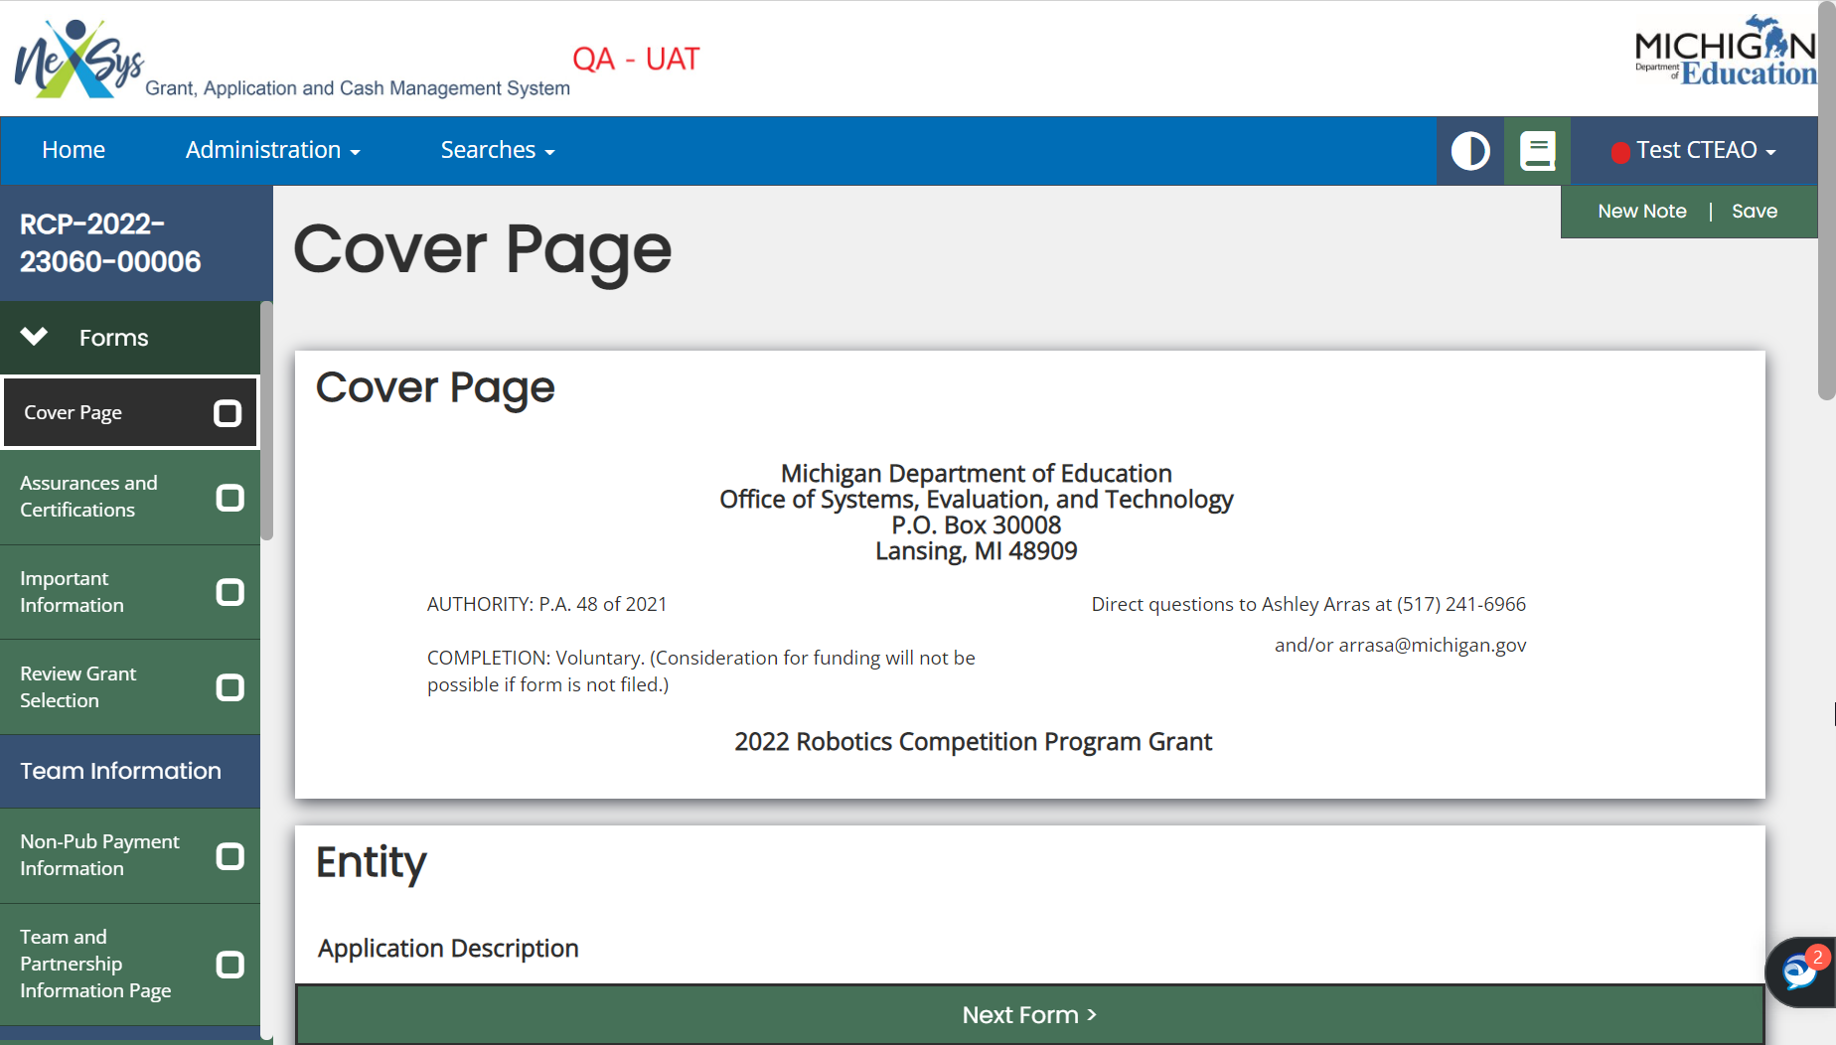
Step 6: Enter the Main Contact Person. You can select a Secondary Contact Person; however, this is not required.
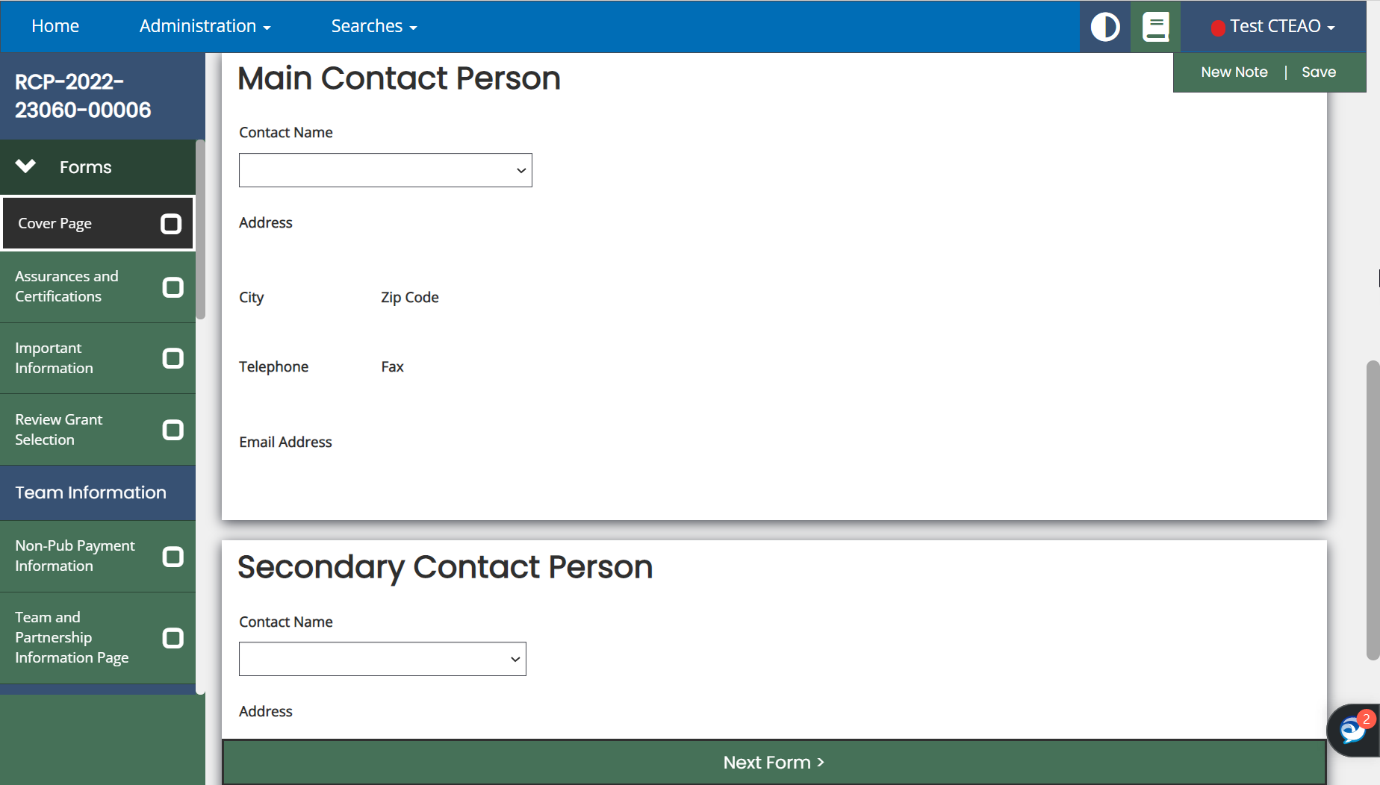

Step 7: Review the Assurances and Certifications and Important Information pages. Click Save and use the left hand navigation menu to Review Grant Selection.
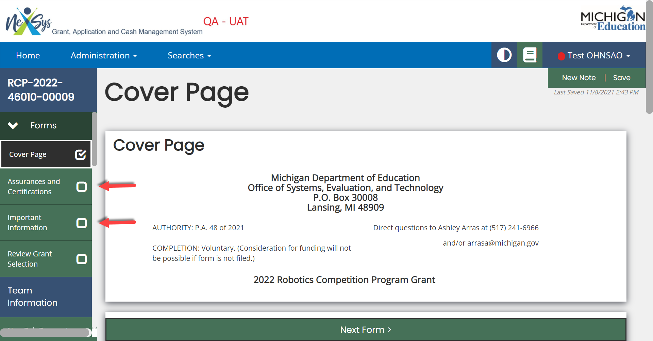

Step 8: On the Review Grant Selection page choose Apply Now if you are ready to apply. Click Save and Next Form. 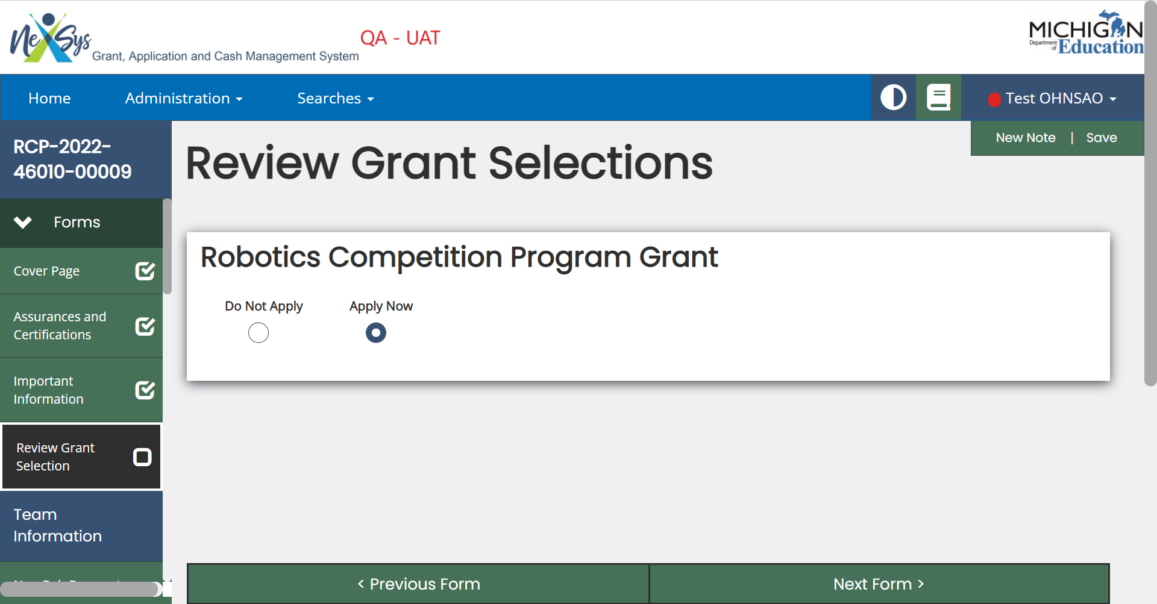

Nonpublic Schools Only: Verify your SIGMA Vendor/ConsumerCVode and enter your District’s address code. Public School Applicants will not see this link on the view/edit page.
Note: Only use numbers in this field. Ex. 001, 002, etc.
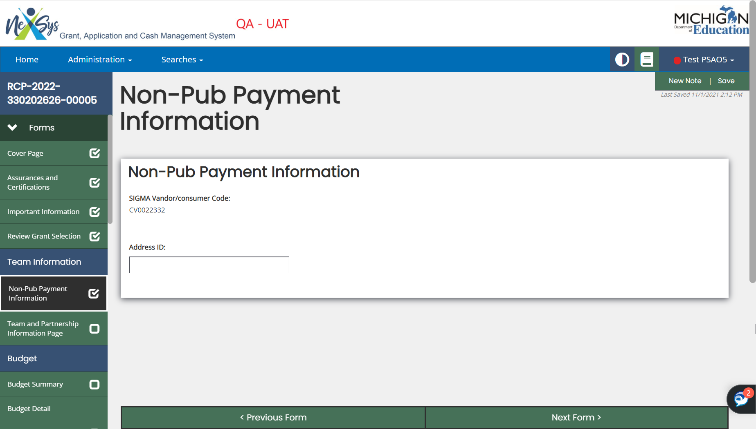
Step 9: On the Team and Partnership Information page fill out the required fields for each individual team. Upon completing the required fields for each team click Save and then Add. These buttons are located in the upper right-hand corner of the application. After each team is added click the Save button. Use the left hand navigation pane to go to the Team and Partnership Information page.
Note: If your FRC team age is 5 years or older choose "FRC- 5th year" which is the catch-all category for teams 5 years old and older.

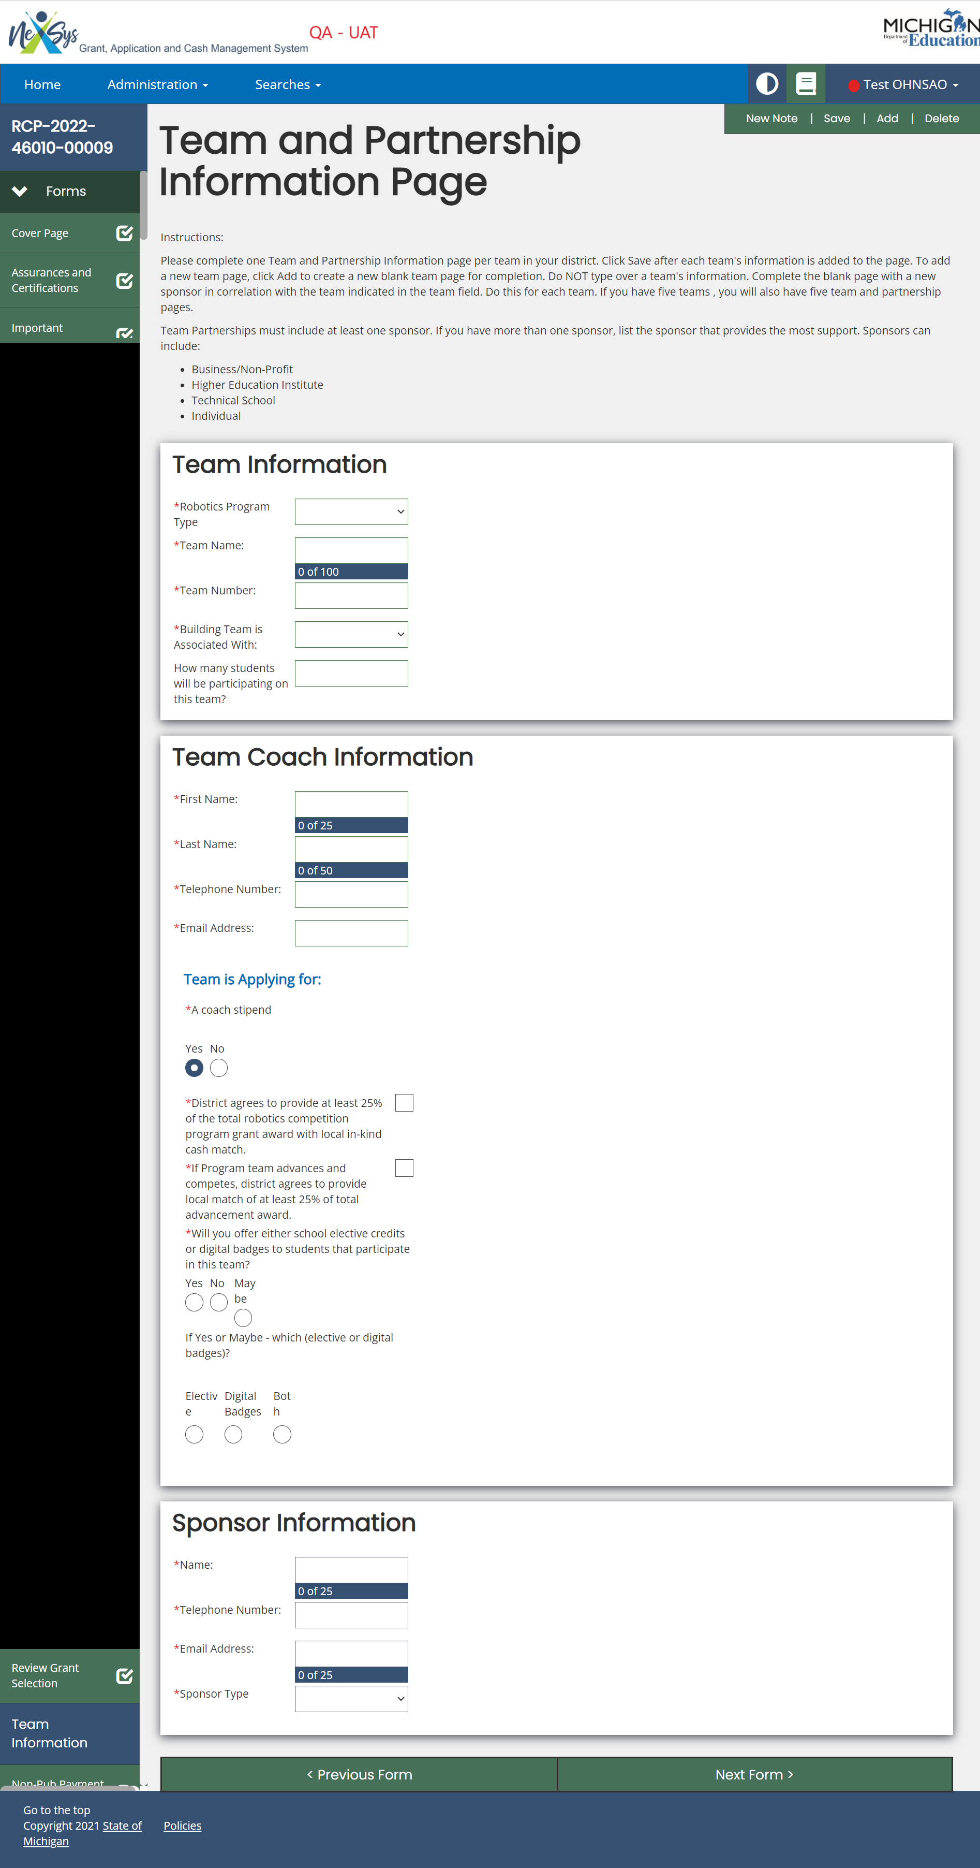
Note: by clicking on the left-hand side menu you can view/navigate between your teams pages.
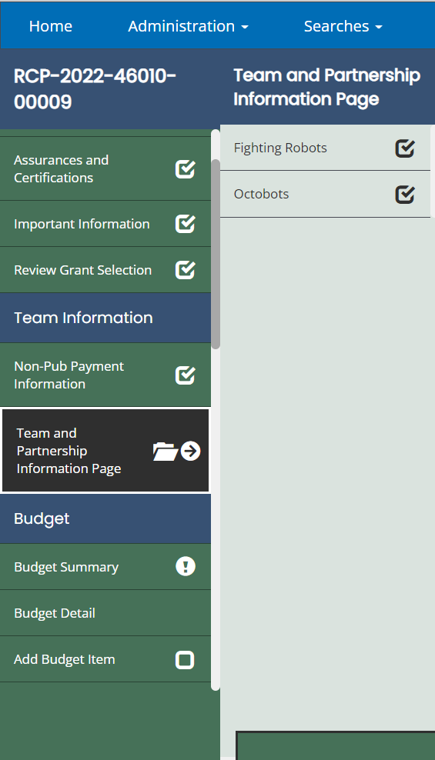
Step 10: On the Budget Summary screen scroll to the bottom and fill out the Contact Information section of this page. Once complete, hit Save, and then from the left-hand navigation page go to Add Budget Item.

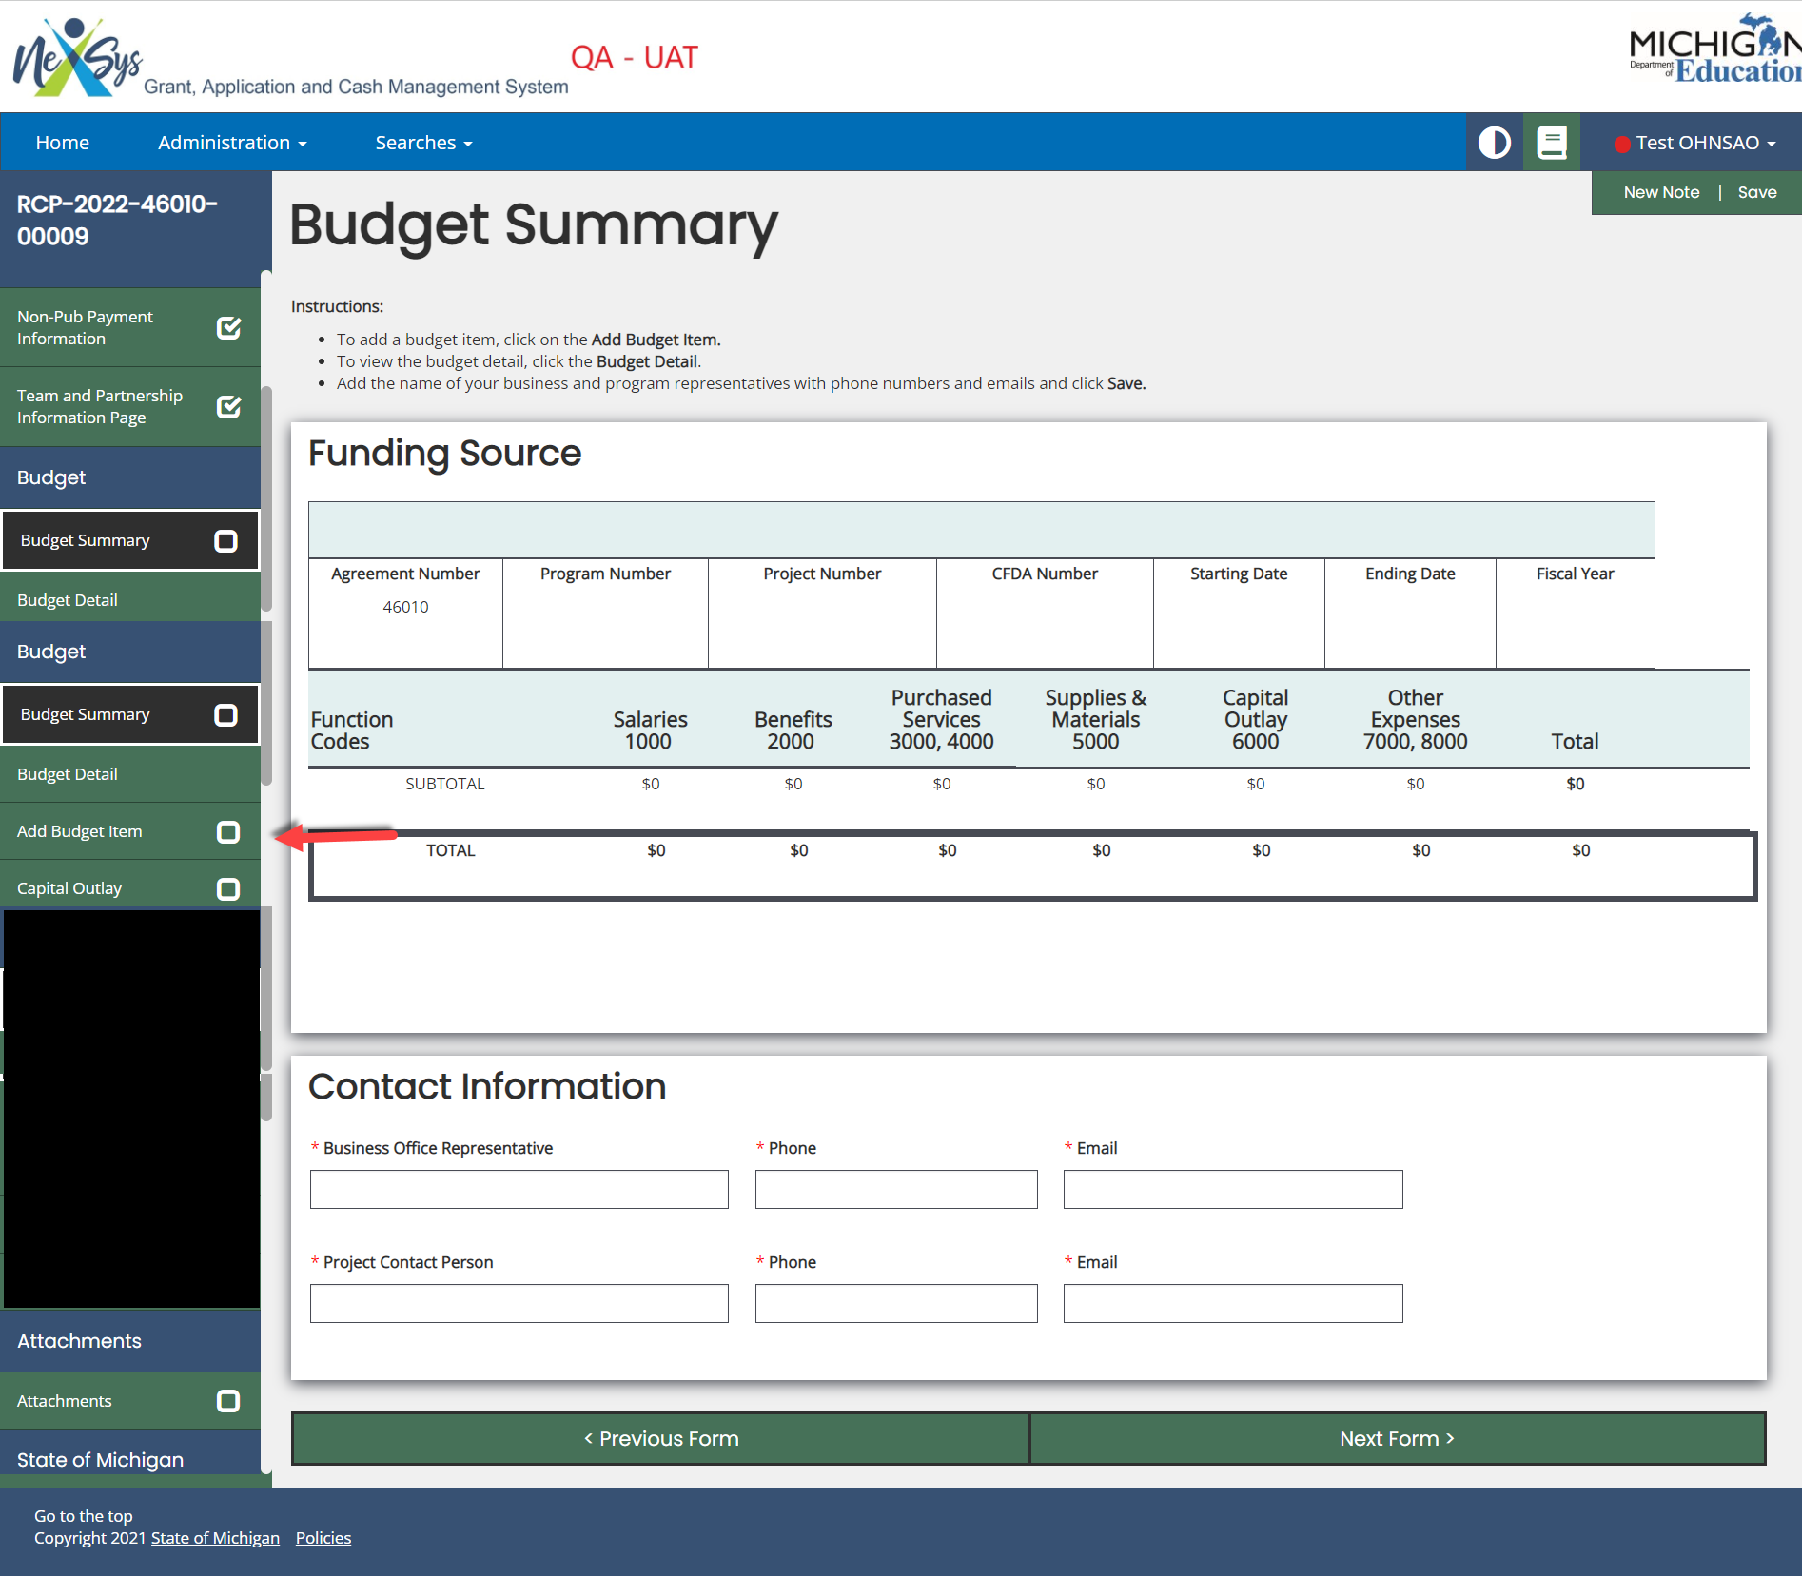
Step 11: Fill out the required fields for each line item on the Budget Items page, click Save, and then Add.

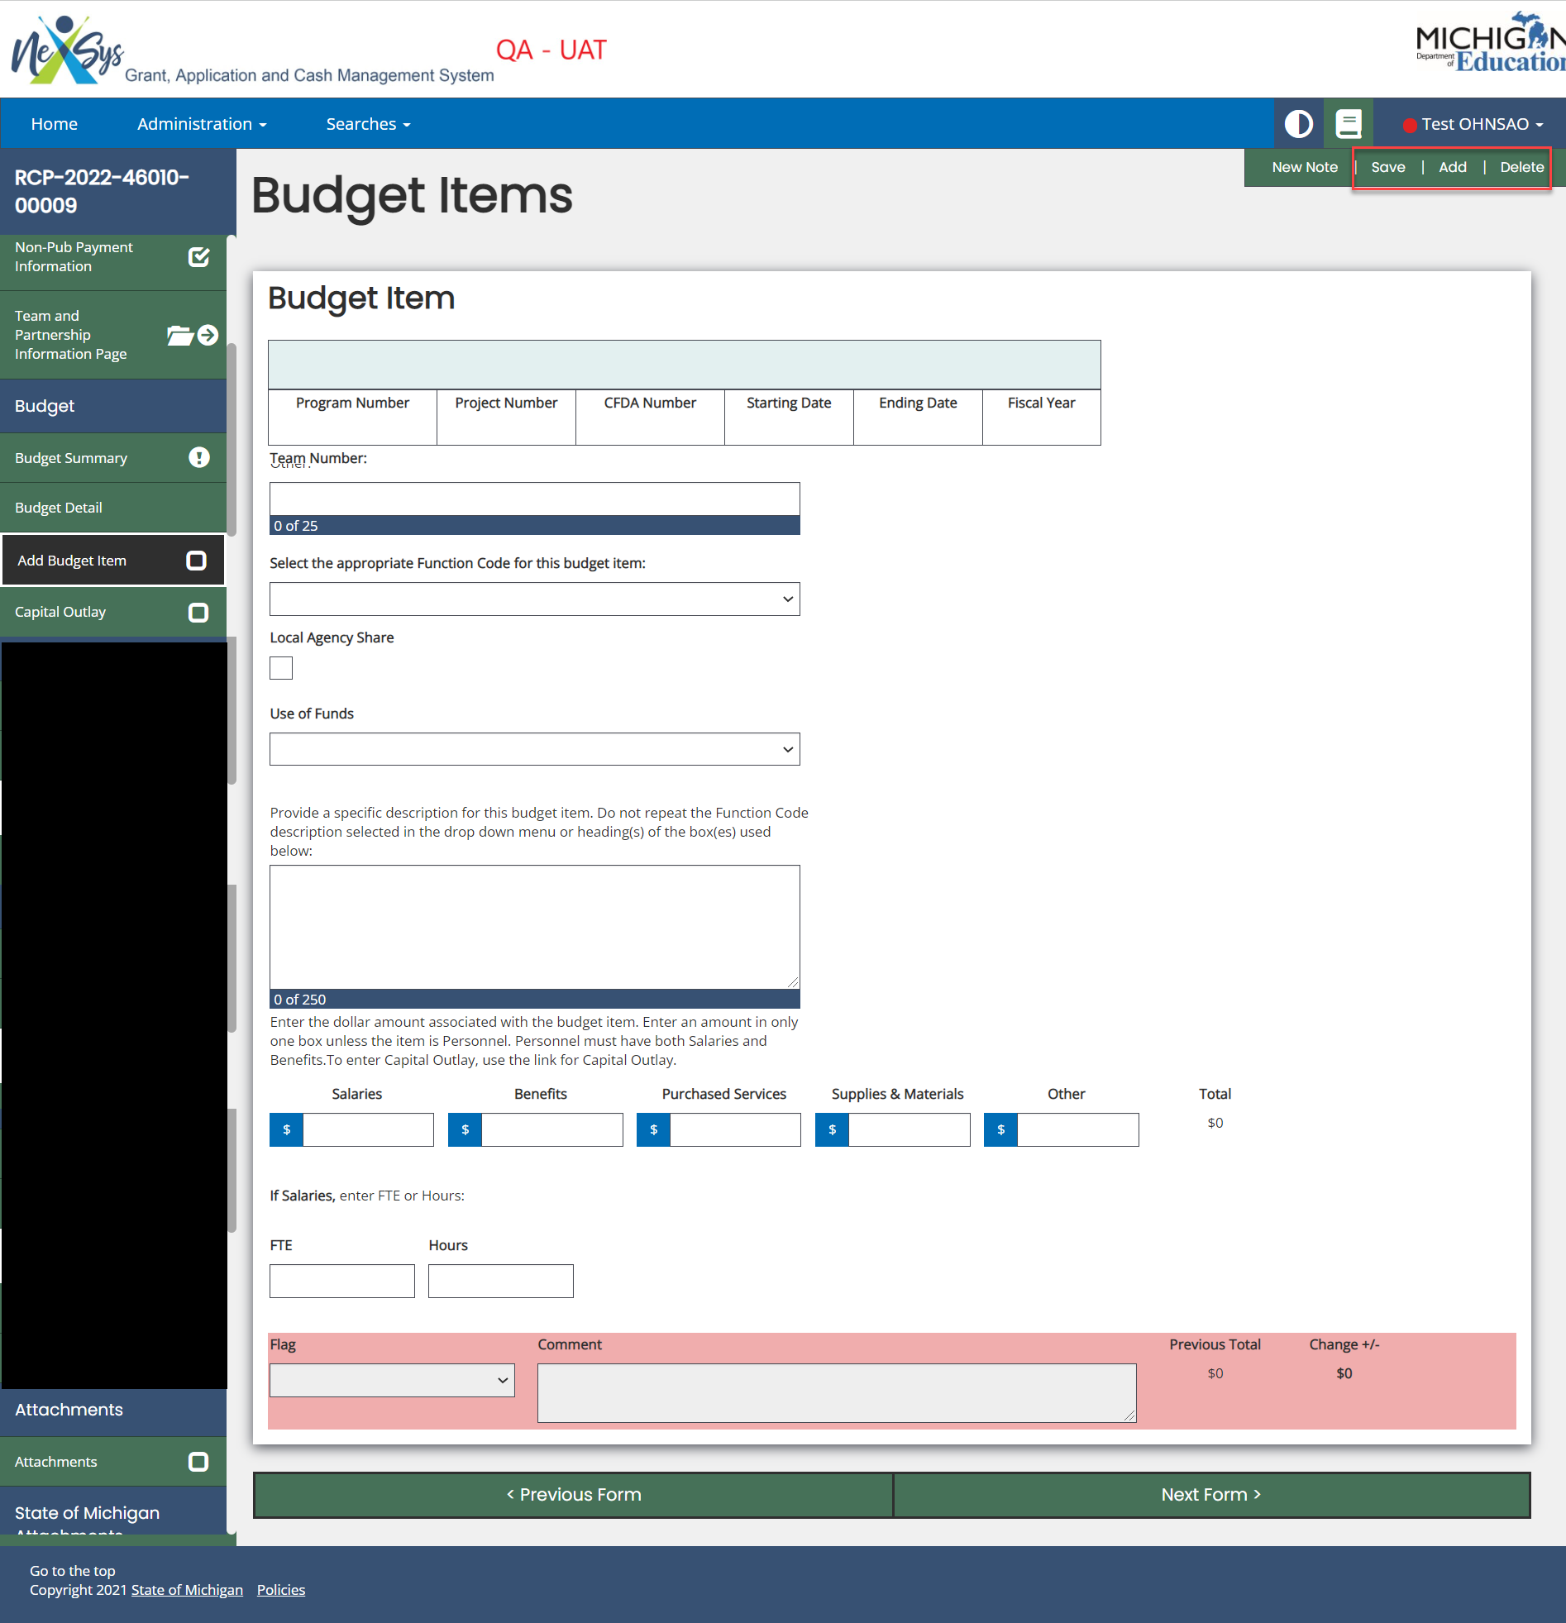

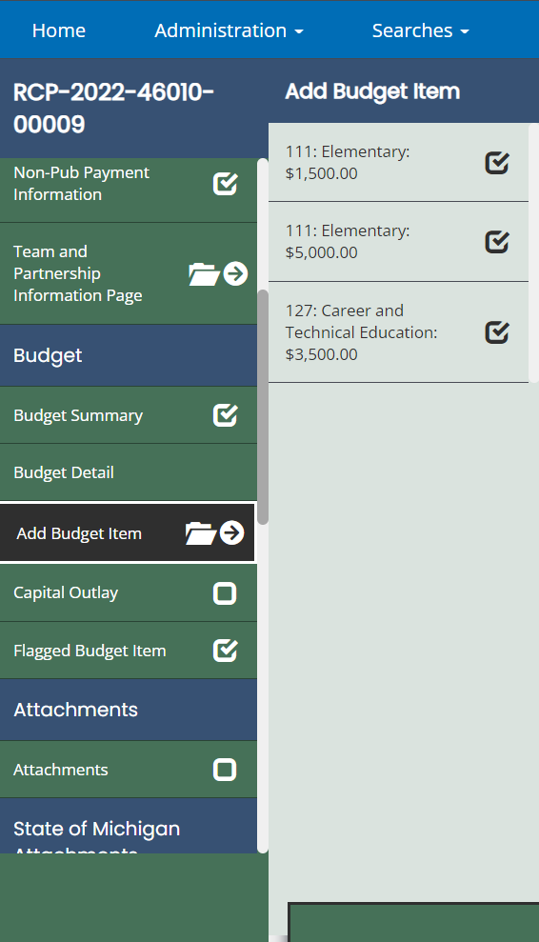
Note: Once you start to add Budget Items you can hover over the left-hand navigation pane to view all of your budget items.
Step 12: On the left-hand menu, navigate to the Attachments menu item.
Upload your Student Roster. Click Save.
Step 13: Now you can submit your application by clicking on Submit in the left hand corner menu.

